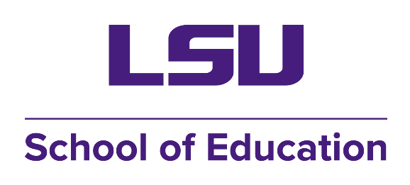

# PLANNED PROGRAM OF STUDY

**MASTERS OF EDUCATION WITH CONCENTRATION IN**

**SCHOOL COUNSELING**

The LSU School Counseling Program recruits and trains self-motivated counselors who are educational leaders and serve as advocates for all students in elementary, middle, and secondary schools. Through engaging caregivers and community partnerships, students demonstrate how school counselors work to promote academic success for all students, serve as multi-systemic leaders and change agents to improve educational practices, and demonstrate counseling effectiveness in removing barriers to success for all students through ongoing outcome research and program evaluation.

## Fall (1st Year)

ELRC 4360 Introduction to School Counseling (3)

ELRC 7331 Counseling Theory and Techniques (3)

ELRC 7391 Counseling Across the Lifespan (3)

## Spring (1st Year)

ELRC 7326 K-12 Career and College Readiness (3)-even years

ELRC 4361 Counseling Children (3)-odd years

ELRC 7330 Group Counseling (3)

## Summer (1st Year)

Elective

## Fall (2nd Year)

ELRC 7345 Counseling Skills and Interventions (3)

ELRC 7393 Multicultural Counseling (30)

ELRC 4362 Introduction to Counseling

## Spring (2nd Year)

ELRC 7362 Practicum (6)

ELRC 7395 Family Counseling (3)

## Summer (2nd Year)

ELRC 7348 Substance Use Problems (3)

## Fall (3rd Year)

ELRC 7399 School Internship (3)

ELRC 7393 Vocational Counseling (3)

ELRC 4249 Understanding Research (3)

## Spring (3rd Year)

ELRC 7399 School Internship (3)

ELRC 7333 Analysis of the Individual (3)

Intern Development Course

In addition to core courses, students will have the opportunity to choose six (6) hours of electives. Some options are listed below:

ELRC 4600 Counseling for Disabling Conditions (3)

ELRC 4603 Crisis and Trauma (Summer) (3)

ELRC 5300 Girls and Women’s Issues in Counseling (3)

ELRC 7396 Grief & Bereavement Counseling

ELRC 7398 Couples Counseling & Marriage Counseling

ELRC ELRC 7600 Issues of Race and Gender in Higher Education

POLI 4027 Politics of Sexual Diversity OR SW 7406 Social work with Lesbian, Gay, Bisexual and Transgender People

EDCI 7764 Social and Emotional Development of the Gifted